f-ref = 50

P-ref = 1000

Q-ref = 0

V-n = 311

R-L = 380^2/8e3 = 18.05

R-step = 380^2/8e3 = 18.05

0.4s 并联接入干扰， 0.8s 干扰断开

J = 0.5

D = 20

测试
f

wt

Sin_Cos

Vd

Vq

Is_d

Is_q

Id

Iq

Pe

在 J = 0.5、D = 20 条件下，系统在 0.4 s 负载突加与 0.8 s 负载切除工况下保持稳定运行。扰动期间有功功率与 dq 电流快速上升，表明系统能够及时响应负载变化；与此同时，频率偏差与 RoCoF 极小，说明当前控制结构下频率被强力抑制。相比之下，电压暂降更为显著，负载接入瞬间电压幅值最大下降约 22%，表明该工况下系统动态瓶颈主要体现在电压支撑而非频率支撑。

clc;

%% ===== 1) 工况参数 =====
f_ref = 50;
P_ref = 1000;
Q_ref = 0;
V_n = 311;

R_L = 18.05;
R_step = 18.05;

t_on = 0.4;
t_off = 0.8;

tol_f = 0.02; % Hz
tol_P = 0.02; % 2%
tol_V = 0.02; % 2%

fprintf('===== 工况信息 =====\n');
fprintf('f_ref = %.3f Hz\n', f_ref);
fprintf('P_ref = %.3f\n', P_ref);
fprintf('Q_ref = %.3f\n', Q_ref);
fprintf('V_n = %.3f\n', V_n);
fprintf('R_L = %.3f Ohm\n', R_L);
fprintf('R_step = %.3f Ohm\n', R_step);
fprintf('t_on = %.3f s\n', t_on);
fprintf('t_off = %.3f s\n', t_off);
fprintf('扰动期间等效负载 R_eq = %.3f Ohm\n', R_L*R_step/(R_L+R_step));

%% ===== 2) 公共时间轴：用 f.Time =====
t = f.Time(:);
fv = squeeze(f.Data);
if isvector(fv), fv = fv(:); end

fprintf('\n参考时间轴: t_start = %.6f s, t_end = %.6f s, N = %d\n', t(1), t(end), numel(t));

%% ===== 3) 定义一个插值函数：把任意 timeseries 插值到 t 上 =====
interp_ts = @(ts, t_ref) interp1( ...
ts.Time(:), ...
reshape(squeeze(ts.Data), [], 1), ...
t_ref, 'linear', 'extrap');

wtv = interp_ts(wt, t);
Vdv = interp_ts(Vd, t);
Vqv = interp_ts(Vq, t);
Isdv = interp_ts(Is_d, t);
Isqv = interp_ts(Is_q, t);
Idv = interp_ts(Id, t);
Iqv = interp_ts(Iq, t);
Pev = interp_ts(Pe, t);

Vmag = sqrt(Vdv.^2 + Vqv.^2);
RoCoF = gradient(fv, t);

%% ===== 4) 时间窗口 =====
idx_pre = find(t >= 0.30 & t < t_on);
idx_on = find(t >= t_on & t < t_off);
idx_off = find(t >= t_off);

fprintf('\n窗口点数:\n');
fprintf('idx_pre = %d\n', numel(idx_pre));
fprintf('idx_on = %d\n', numel(idx_on));
fprintf('idx_off = %d\n', numel(idx_off));

if isempty(idx_pre), error('扰动前窗口 0.30~0.40 s 为空'); end
if isempty(idx_on), error('扰动作用窗口 0.40~0.80 s 为空'); end
if isempty(idx_off), error('扰动解除后窗口 0.80 s 以后为空'); end

%% ===== 5) 扰动前稳态基准 =====
f0 = mean(fv(idx_pre));
P0 = mean(Pev(idx_pre));
V0 = mean(Vmag(idx_pre));
Id0 = mean(Idv(idx_pre));
Iq0 = mean(Iqv(idx_pre));

fprintf('\n===== 扰动前稳态基准 (0.30~0.40 s) =====\n');
fprintf('f0 = %.6f Hz\n', f0);
fprintf('P0 = %.6f\n', P0);
fprintf('V0 = %.6f\n', V0);
fprintf('Id0 = %.6f\n', Id0);
fprintf('Iq0 = %.6f\n', Iq0);

%% ===== 6) 0.4s 接入扰动 =====
f_on = fv(idx_on);
P_on = Pev(idx_on);
V_on = Vmag(idx_on);
Id_on = Idv(idx_on);
Iq_on = Iqv(idx_on);
Isd_on = Isdv(idx_on);
Isq_on = Isqv(idx_on);
R_on = RoCoF(idx_on);

f_min_on = min(f_on);
f_drop_on = f0 - f_min_on;
RoCoF_on_max = max(abs(R_on));

P_peak_on = max(P_on);
P_rise_on = P_peak_on - P0;

V_min_on = min(V_on);
V_drop_on = V0 - V_min_on;

Id_peak_on = max(abs(Id_on));
Iq_peak_on = max(abs(Iq_on));
Isd_peak_on = max(abs(Isd_on));
Isq_peak_on = max(abs(Isq_on));

% 接入后新稳态估计：0.70~0.80s
idx_on_ss = find(t >= 0.70 & t < 0.80);
if isempty(idx_on_ss)
idx_on_ss = idx_on(round(0.8*numel(idx_on)):end);
end

f_on_ss = mean(fv(idx_on_ss));
P_on_ss = mean(Pev(idx_on_ss));
V_on_ss = mean(Vmag(idx_on_ss));

Ts_f_on = NaN;
for k = 1:numel(idx_on)
j = idx_on(k:end);
if all(abs(fv(j) - f_on_ss) <= tol_f)
Ts_f_on = t(idx_on(k)) - t_on;
break;
end
end

Ts_P_on = NaN;
for k = 1:numel(idx_on)
j = idx_on(k:end);
if all(abs(Pev(j) - P_on_ss) <= max(abs(P_on_ss)*tol_P,1e-6))
Ts_P_on = t(idx_on(k)) - t_on;
break;
end
end

Ts_V_on = NaN;
for k = 1:numel(idx_on)
j = idx_on(k:end);
if all(abs(Vmag(j) - V_on_ss) <= max(abs(V_on_ss)*tol_V,1e-6))
Ts_V_on = t(idx_on(k)) - t_on;
break;
end
end

%% ===== 7) 0.8s 断开扰动 =====
f_off = fv(idx_off);
P_off = Pev(idx_off);
V_off = Vmag(idx_off);
Id_off = Idv(idx_off);
Iq_off = Iqv(idx_off);
Isd_off = Isdv(idx_off);
Isq_off = Isqv(idx_off);
R_off = RoCoF(idx_off);

f_max_off = max(f_off);
f_rise_off = f_max_off - f0;
RoCoF_off_max = max(abs(R_off));

P_min_off = min(P_off);
P_drop_off = P0 - P_min_off;

V_max_off = max(V_off);
V_rise_off = V_max_off - V0;

Id_peak_off = max(abs(Id_off));
Iq_peak_off = max(abs(Iq_off));
Isd_peak_off = max(abs(Isd_off));
Isq_peak_off = max(abs(Isq_off));

Ts_f_off = NaN;
for k = 1:numel(idx_off)
j = idx_off(k:end);
if all(abs(fv(j) - f0) <= tol_f)
Ts_f_off = t(idx_off(k)) - t_off;
break;
end
end

Ts_P_off = NaN;
for k = 1:numel(idx_off)
j = idx_off(k:end);
if all(abs(Pev(j) - P0) <= max(abs(P0)*tol_P,1e-6))
Ts_P_off = t(idx_off(k)) - t_off;
break;
end
end

Ts_V_off = NaN;
for k = 1:numel(idx_off)
j = idx_off(k:end);
if all(abs(Vmag(j) - V0) <= max(abs(V0)*tol_V,1e-6))
Ts_V_off = t(idx_off(k)) - t_off;
break;
end
end

%% ===== 8) 输出结果 =====
fprintf('\n================ 0.4 s 接入扰动（加负载） ================\n');
fprintf('频率最低值 = %.6f Hz\n', f_min_on);
fprintf('最大频率跌落 = %.6f Hz\n', f_drop_on);
fprintf('最大 |RoCoF| = %.6f Hz/s\n', RoCoF_on_max);
fprintf('频率恢复时间 = %.6f s\n', Ts_f_on);

fprintf('功率峰值 = %.6f\n', P_peak_on);
fprintf('功率增加量 = %.6f\n', P_rise_on);
fprintf('功率恢复时间 = %.6f s\n', Ts_P_on);

fprintf('电压最小值 = %.6f\n', V_min_on);
fprintf('最大电压跌落 = %.6f\n', V_drop_on);
fprintf('电压恢复时间 = %.6f s\n', Ts_V_on);

fprintf('|Id| 最大值 = %.6f\n', Id_peak_on);
fprintf('|Iq| 最大值 = %.6f\n', Iq_peak_on);
fprintf('|Is_d| 最大值 = %.6f\n', Isd_peak_on);
fprintf('|Is_q| 最大值 = %.6f\n', Isq_peak_on);

fprintf('\n================ 0.8 s 断开扰动（卸载） ================\n');
fprintf('频率最高值 = %.6f Hz\n', f_max_off);
fprintf('最大频率上冲 = %.6f Hz\n', f_rise_off);
fprintf('最大 |RoCoF| = %.6f Hz/s\n', RoCoF_off_max);
fprintf('频率恢复时间 = %.6f s\n', Ts_f_off);

fprintf('功率最小值 = %.6f\n', P_min_off);
fprintf('功率下降量 = %.6f\n', P_drop_off);
fprintf('功率恢复时间 = %.6f s\n', Ts_P_off);

fprintf('电压最高值 = %.6f\n', V_max_off);
fprintf('最大电压上冲 = %.6f\n', V_rise_off);
fprintf('电压恢复时间 = %.6f s\n', Ts_V_off);

fprintf('|Id| 最大值 = %.6f\n', Id_peak_off);
fprintf('|Iq| 最大值 = %.6f\n', Iq_peak_off);
fprintf('|Is_d| 最大值 = %.6f\n', Isd_peak_off);
fprintf('|Is_q| 最大值 = %.6f\n', Isq_peak_off);

%% ===== 9) 作图 =====
figure;
plot(t, fv, 'LineWidth', 1.2); grid on; hold on;
xline(t_on, '--r', '0.4s on');
xline(t_off, '--k', '0.8s off');
xlabel('Time (s)'); ylabel('f (Hz)');
title('Frequency Response');

figure;
plot(t, Pev, 'LineWidth', 1.2); grid on; hold on;
xline(t_on, '--r', '0.4s on');
xline(t_off, '--k', '0.8s off');
xlabel('Time (s)'); ylabel('Pe');
title('Active Power Response');

figure;
plot(t, Vmag, 'LineWidth', 1.2); grid on; hold on;
xline(t_on, '--r', '0.4s on');
xline(t_off, '--k', '0.8s off');
xlabel('Time (s)'); ylabel('|V|');
title('Voltage Magnitude Response');

figure;
plot(t, Idv, 'LineWidth', 1.2); hold on;
plot(t, Iqv, 'LineWidth', 1.2); grid on;
xline(t_on, '--r', '0.4s on');
xline(t_off, '--k', '0.8s off');
xlabel('Time (s)'); ylabel('Current');
legend('Id','Iq');
title('dq Current Response');

figure;
plot(t, RoCoF, 'LineWidth', 1.2); grid on; hold on;
xline(t_on, '--r', '0.4s on');
xline(t_off, '--k', '0.8s off');
xlabel('Time (s)'); ylabel('RoCoF (Hz/s)');
title('RoCoF');

===== 工况信息 =====
f_ref = 50.000 Hz
P_ref = 1000.000
Q_ref = 0.000
V_n = 311.000
R_L = 18.050 Ohm
R_step = 18.050 Ohm
t_on = 0.400 s
t_off = 0.800 s
扰动期间等效负载 R_eq = 9.025 Ohm

参考时间轴: t_start = 0.000000 s, t_end = 1.500000 s, N = 1500001

窗口点数:
idx_pre = 100001
idx_on = 400000
idx_off = 700000

===== 扰动前稳态基准 (0.30~0.40 s) =====
f0 = 50.000273 Hz
P0 = 8519.637984
V0 = 320.192208
Id0 = 7.862386
Iq0 = 15.819234

================ 0.4 s 接入扰动（加负载） ================
频率最低值 = 50.000321 Hz
最大频率跌落 = -0.000048 Hz
最大 |RoCoF| = 0.000989 Hz/s
频率恢复时间 = 0.000001 s
功率峰值 = 12883.723737
功率增加量 = 4364.085753
功率恢复时间 = 0.001085 s
电压最小值 = 249.422640
最大电压跌落 = 70.769569
电压恢复时间 = 0.000724 s
|Id| 最大值 = 21.783747
|Iq| 最大值 = 26.584414
|Is_d| 最大值 = 22.461371
|Is_q| 最大值 = 26.717306

================ 0.8 s 断开扰动（卸载） ================
频率最高值 = 50.000567 Hz
最大频率上冲 = 0.000294 Hz
最大 |RoCoF| = 0.000971 Hz/s
频率恢复时间 = 0.000001 s
功率最小值 = 8498.801213
功率下降量 = 20.836770
功率恢复时间 = 0.007897 s
电压最高值 = 321.674074
最大电压上冲 = 1.481866
电压恢复时间 = 0.000001 s
|Id| 最大值 = 21.875881
|Iq| 最大值 = 17.820581
|Is_d| 最大值 = 22.544501
|Is_q| 最大值 = 17.979439

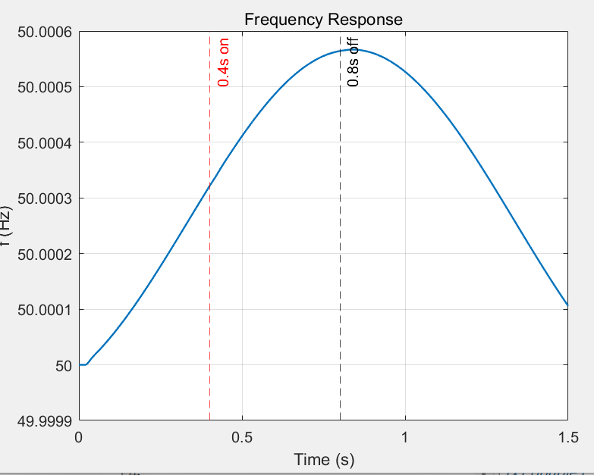

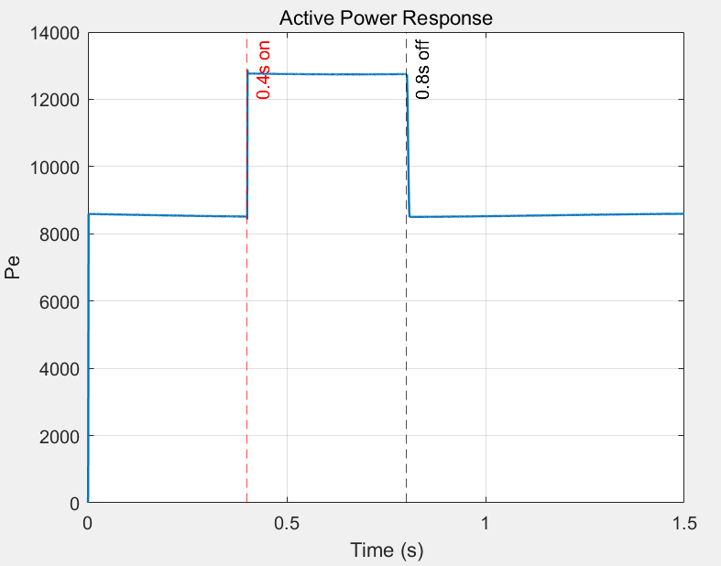

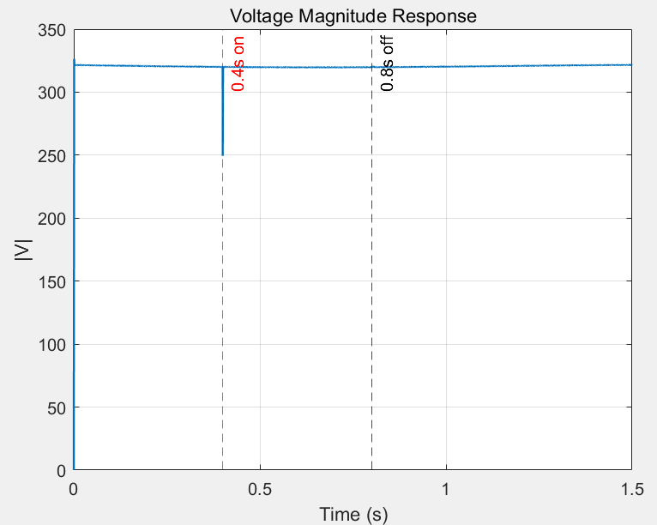

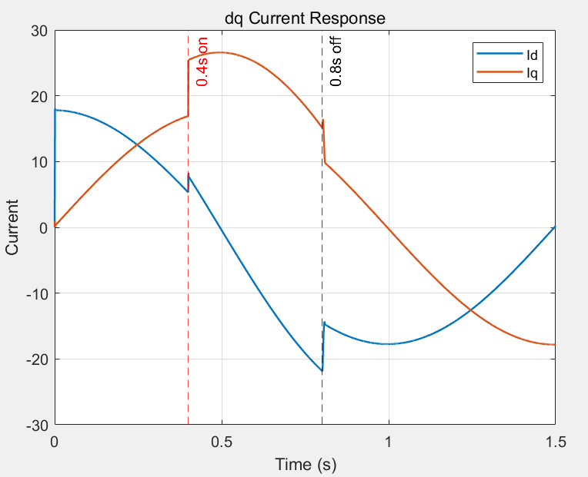

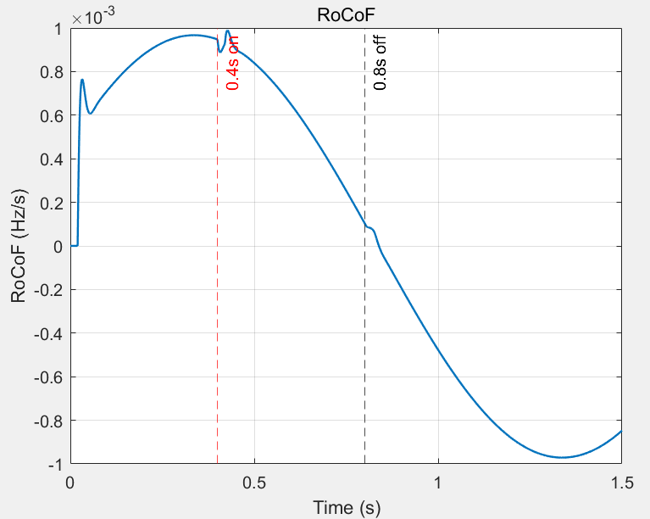

在孤岛运行条件下，采用 $J=0.5$、$D=20$ 的 VSG 参数时，系统在负载接入与切除扰动下均保持稳定运行。仿真结果表明，频率波动很小，系统无持续振荡，功率、电流及电压均能在短时间内恢复至稳定状态。因此，该组参数可视为一组可行且具有较好稳定性的基础参数，为后续参数优化与自适应控制研究提供了有效起点。

